CS 514

Applied Artificial Intelligence

Project 4

Bayesian Medical Decision Network

A Probabilistic health care System for diagnostics

INDEX

|  |  |
| --- | --- |
| Topic | Page number |
| Abstract | 3 |
| Features of the Bayesian Diagnostic Decision Network | 3 |
| Usage Manual | 4 |

# Abstract:

Bayesian Medical Expert system is a probabilistic inference system that assesses the probability of a patient having a heart related disease and diabetes. The system takes into account numerous symptoms into consideration and build a Bayesian Network on the basis of that. The symptoms for heart diseases and diabetes are categorized into three main parts viz. less critical symptom, medium critical symptoms and very critical symptoms. The conditional probability tables of these are generated by individual root node symptoms that can be **directly observed** by a physician. Many of the symptoms are qualitative and it is not possible to quantify it because of which existence of a probabilistic system is highly beneficial.

The relationships between various stages can be clearly represented by the Bayesian Network.

There are additional utility nodes that describe a cost in terms of score out of 100 for picking a certain decision. For instance, if a patient with no disorder is subject to test, then the system is subject to a negative penalty.

# Usage Manual:

Copy the file BayesianDiagnosticDecisionNetwork.dne in any location and open the file in Netica. Compile the network and input values by clicking on all the root nodes (node without parents) to see the changes flowing through the Bayesian Network.

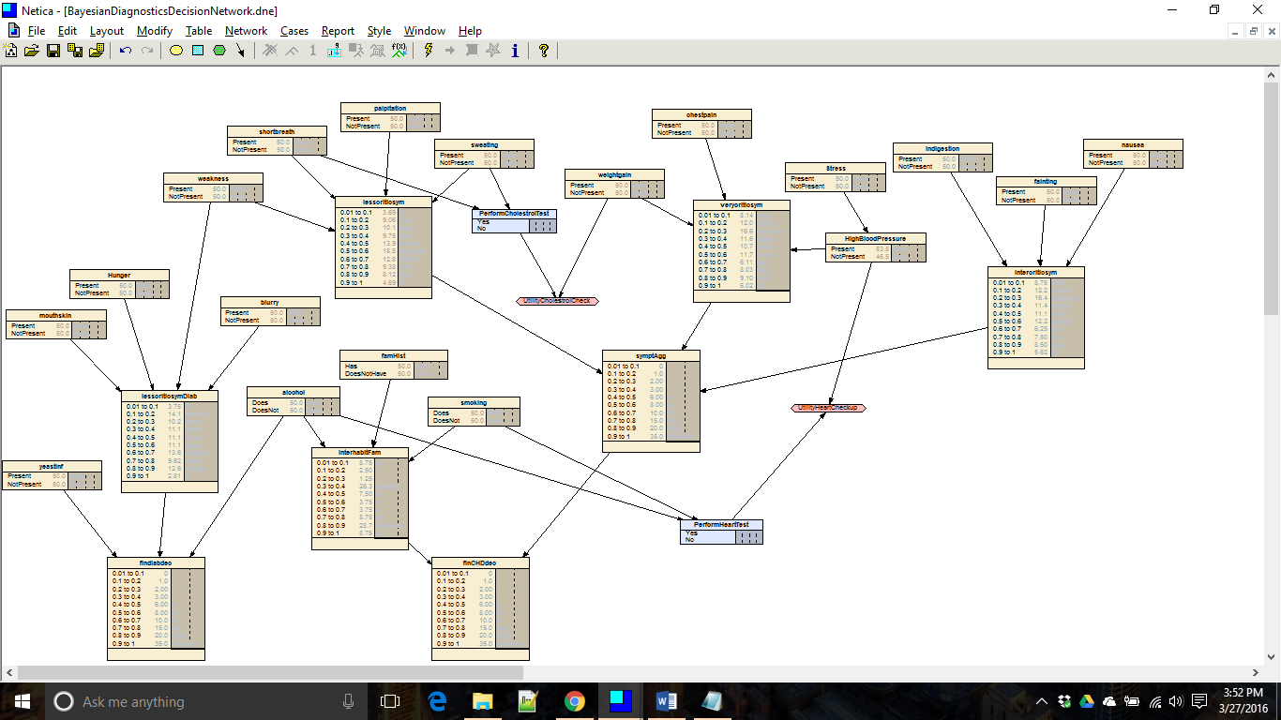

Utility nodes have been added that assist Netica to optimize the cost of the utility network. Maximum cost is derived when no tests are to be conducted without any symptoms. In other words, that would make the patient the most happy. On the other hand, if the symptoms are high and the diagnostic system decides to not make the decision of asking the patient to go for a test then the system will be highly penalized.

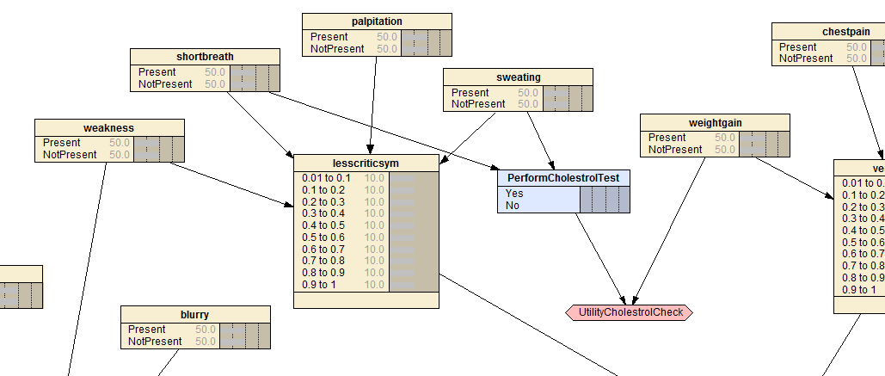

There are two utility nodes that have been added. One for cholesterol test utility and another for Coronary heart diseases test i.e. an Electro cardiogram test. Also note that, Netica **adds multiple edges automatically during compile time**. The output network is as below.

